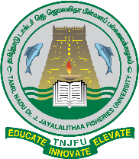
TAMIL NADU Dr.J.JAYALALITHAA FISHERIES UNIVERSITY

No:202/DR/TNJFU/IQAC/Minutes/2024 | Directorate of Research  Vettar River View Campus Nagapattinam - 611 002.
Minutes of the IQAC 4th quarterly meeting University level by inviting Guest Speakers
Date & Mode : 27.11.2024 & Virtual
The University level 4th Quarterly meeting on Internal Quality Assurance was conducted on 27.11.2024 at 11.00 am through virtual mode. The following members were present in the IQAC meeting.
Sl.  No. | Name of the Officials | Designation
1. | Dr. N. Felix | Chairperson and Vice-Chancellor, TNJFU,  Nagapattinam
2. | Dr. M. Rajakumar | Member Secretary and Director of Research i/c, TNJFU, Nagapattinam
3. | Dr.P.Chidambaram | Senior Administrative Staff Member and Registrar, TNJFU, Nagapattinam
4. | Th.S.  Thirugnanasambandam | Senior Administrative Staff Member and Finance Officer i/c., TNJFU, Nagapattinam
5. | Dr. M. Chinnadurai | Guest Speaker - Professor & NAAC Evaluator, Dept. of Computer Science Engineering,  E.G.S. Pillay Engineering College (Autonomous), Nagapattinam – 611 002
6. | Dr. V.P. Harigovindan | External Expert - Associate Professor & Head, Dept. of Electronics & Communication Engineering, National Institute of Technology,  Karaikal, Union Territory of Puducherry – 609 609
7. | Dr. K. Ravaneswaran | Member and Controller of Examination i/c, TNJFU, Nagapattinam
8. | Dr. Padmavathy | Member and Director of Extension Education  i/c., TNJFU, Nagapattinam
9. | Dr. Cheryl Antony | Member and Director of Sustainable Aquaculture  i/c., TNJFU, Nagapattinam
10. | Er. C. Nambirajan | Member and Estate Officer i/c., TNJFU, Nagapattinam
11. | Dr. B. Ahilan | Member and Dean, Fisheries College and Research Institute, Thoothukudi
12. | Dr. R. Jeya Shakila | Member & Dean,  Dr. MGR Fisheries College and Research Institute, Ponneri

13. | Dr. Mohammed Tanveer | Member & Dean i/c.,  College of Fisheries Engineering, Nagapattinam
14. | Dr. K. Veerabhadran | Member & Dean i/c., Dr. MGR Fisheries College and Research Institute, Thalainayeru
15. | Dr. S. Balasundari | Member and Dean of Basic Science  Institute of Fisheries Post Graduate Studies, Vaniyanchavadi, OMR, Chennai
16. | Dr. Usha Antony | Member and Dean  College of Fish Nutrition and Food Technology, Madhavaram, Chennai
17 | Dr.A.Uma | Member and Director DIVA,Muttukadu, Chennai
18. | Dr. N. Neethiselvan | Member and Director i/c DIVF,AriyamanBeach, Ramanathapuram

- Meeting Inauguration

The meeting commenced with the formal inauguration by the Vice-Chancellor of Tamil Nadu Dr. J. Jayalalithaa Fisheries University (TNJFU). The Vice-Chancellor extended a warm welcome to all present and highlighted the importance of this meeting for continuing the University's commitment towards quality enhancement and academic excellence.
- Welcome Address

The welcome address was delivered by the Member Secretary of the Internal Quality Assurance Cell (IQAC). He welcomed all the University Officers, College Deans, Directors, and the invited Guest Speaker, Dr. Chinnadurai, Professor and NAAC Evaluator. The Member Secretary emphasized the significance of this meeting as a platform for sharing the best practices and engaging in meaningful discussions towards the improvement of quality standards across the University and its constituent colleges
- Vice-Chancellor’s Address

The Vice-Chancellor gave a comprehensive briefing about the IQAC activities undertaken during the previous quarter across the University and its constituent colleges. The Vice-Chancellor emphasized the University’s commitment to continuous quality improvement and the ongoing efforts to meet NAAC accreditation standards.

Furthermore, the Vice-Chancellor directed that a robust feedback system to be initiated towards Research and Extension activities to further strengthen the outcome of quality in these domains. The feedback system should be designed to capture key insights and contribute to enhancing research impact and community outreach.
- Presentation of IQAC Activities

The Chairperson’s of IQAC from the respective constituent colleges of TNJFU presented the activities undertaken by their IQACs during the 3rd quarter. All the activities (i.e) Meeting Minutes, Action Taken Report on the minutes discussed in the meeting, IQAC Quarterly report were ensured timely submission to the University. These included initiatives aimed at quality improvement, faculty development programs, student engagement, and research activities. Additionally, the colleges outlined their plans for the upcoming 4th quarter, which included further steps to address areas identified for improvement.

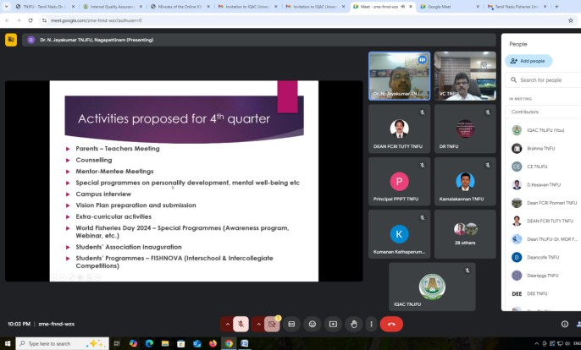 | 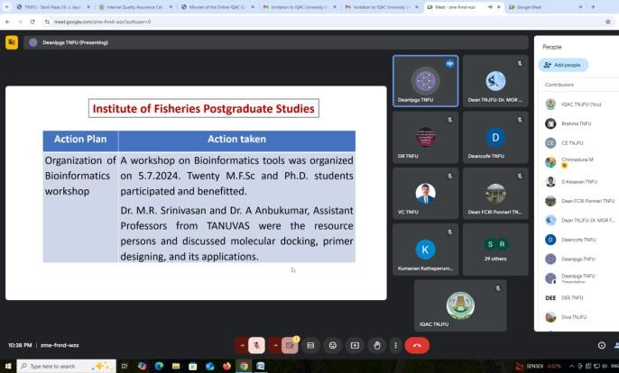

- Guest Speaker’s Presentation

The invited Guest Speaker, Dr. Chinnadurai, Professor and NAAC Evaluator, shared his vast experience as a NAAC Coordinator. Dr. Chinnadurai provided a detailed presentation on the Self Study Criteria for NAAC Accreditation and Assessment. He emphasized the importance of systematically documenting evidence and aligning institutional practices with NAAC’s accreditation framework.

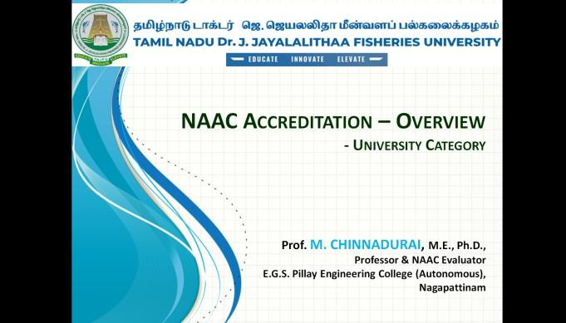 | 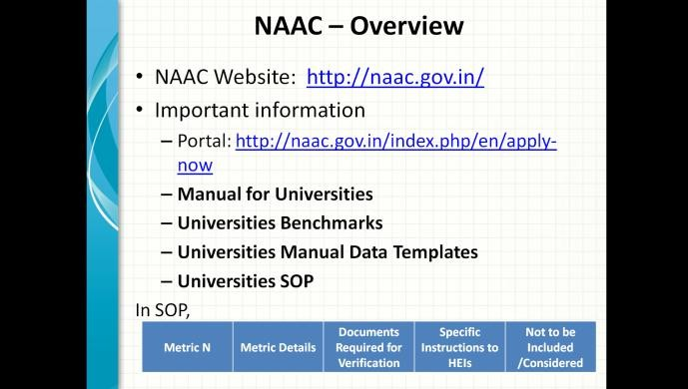
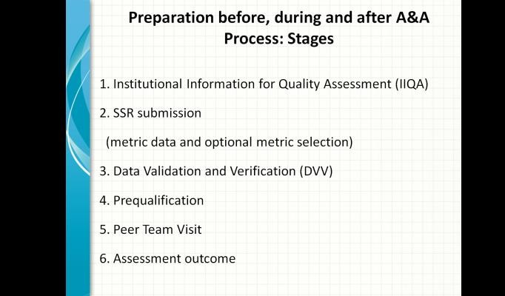 | 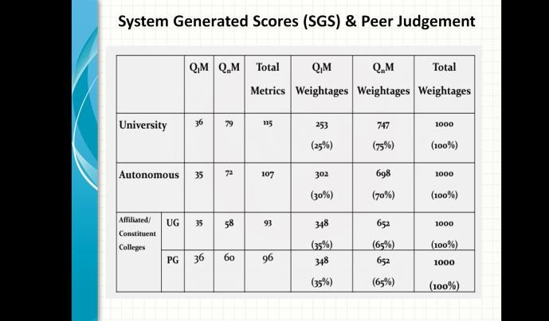

Dr. Chinnadurai also clarified queries raised by the participants during the session, specifically addressing concerns related to NAAC's assessment procedures and the Self Study Report (SSR).


- Discussions and Clarifications

The meeting included an interactive session where Dr. Chinnadurai responded to various queries and provided expert insights on addressing the challenges of NAAC accreditation. The participants engaged in discussions around improving internal quality mechanisms and ensuring compliance with NAAC standards. Dr. Chinnadurai’s valuable suggestions were well received and appreciated by all attendees.

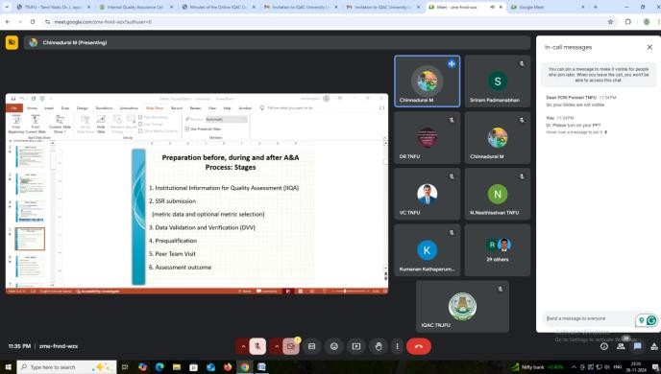 | 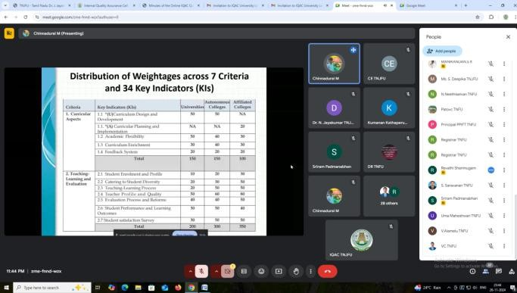

Action Points for Constituent Colleges:

Agenda 1

Existing Feedback System: Ensure Students submission of their Feedback on the 55th and 105th Working Day.
Minute:

  - Instruct all students to submit their feedback on the 55th and 105th working days, as previously informed. These feedback forms are important for monitoring and improving the quality of education and campus services. Direct students to access the online feedback form on the IQAC portal using their provided credentials. Ensure that they complete the feedback on the specified days. Review and confirm with the IQAC office that all students of respective colleges have been informed and are submitting their feedback on time.
(Action: All Deans/Directors)

Agenda 2

Monitor Submission of Feedback Forms by college level admin. Minute:
  - Ensure that all staff members have also been instructed to submit their feedback forms using the provided credentials. This feedback is integral for assessing the quality of teaching, resources, and administration.

Staff should submit their feedback through their respective login credentials on the IQAC portal. Please ensure that staff are aware of the system.
(Action: All Deans/Directors)

Agenda 3

Collect Alumni Feedbacks. Minute:
  - The Alumni feedback form is available on the IQAC portal. Kindly share the URL for the Alumni feedback form with the Alumni members. Send the URL to the alumni through email or WhatsApp, as per the communication channels with them. Instruct alumni to fill out the Alumni feedback form to provide valuable insights into the university’s programs and services.
(Action: All Deans/Directors)

Agenda 4

Collect Employer Feedback. Minute:
  - The Employer feedback form is also available on the IQAC portal. Share the URL with employers or industry partners who have collaborated with your college/institute or placement cell. Distribute the URL through email or other appropriate communication channels. Request employers to provide feedback regarding the quality of students being placed through the college’s placement cell and their preparedness for the workforce.
(Action: All Deans/Directors)

Agenda 5

Collect General Feedback about the College and Placement Cell. Minute:
  - Ensure that feedback regarding the overall functioning of the college and placement cell is collected. Distribute the general feedback URL to students,

staff, and external stakeholders (e.g., parents or community members) via email, WhatsApp, or other communication channels. Encourage stakeholders to provide their feedback regarding their experiences with the college and placement cell to help improve overall services.
(Action: All Deans/Directors)

Agenda 6

Monitoring and Reporting. Minute:
  - Once the feedback has been collected, ensure that the feedback forms are being submitted correctly and are visible on the admin level of the respective colleges. Any discrepancies in the submission should be reported to the IQAC at University level immediately. Deans and Directors should monitor the feedback submission and ensure all relevant groups (students, staff, alumni, employers) are submitting their forms on time.
(Action: All Deans/Directors)

Agenda 7

Compliance and Follow-Up. Minute:
  - Ensure that all feedback forms are completed by the concerned individuals within the given timeframe. It is important to emphasize to all participants that their feedback is essential for the university’s continuous improvement.

  - Instructions: Kindly follow up with any stakeholders who have not yet submitted their feedback to ensure compliance.
(Action: All Deans/Directors)

Agenda 8

Preparation for NAAC Accreditation. Minute:
  - Colleges should review and align their activities with the NAAC accreditation criteria as discussed by Dr. Chinnadurai’s in his presentation. A focus on improving the documentation process and ensuring all evidence required for NAAC accreditation is systematically compiled and easily accessible. Submit a progress report on the preparations for the NAAC assessment.
(Action: All Deans/Directors)

Agenda 9

Quality Enhancement Initiatives. Minute:
    - Based on the feedback from the Vice-Chancellor and Guest Speaker, colleges should introduce new or enhanced initiatives for continuous improvement in teaching, learning, research and student engagement.Colleges are encouraged to incorporate innovative strategies to foster academic excellence and contribute to the holistic development of students.
(Action: All Deans/Directors)

Agenda 10

Strengthening Research and Extension Activities. Minute:
    - Colleges should focus on expanding research and extension activities in line with national and global trends. Promote interdisciplinary research and increase collaboration with industries and other academic

